Sample Social Media
Full sized images available for download at www.WaysToMentalWellbeing.com
Twitter
Cover Image
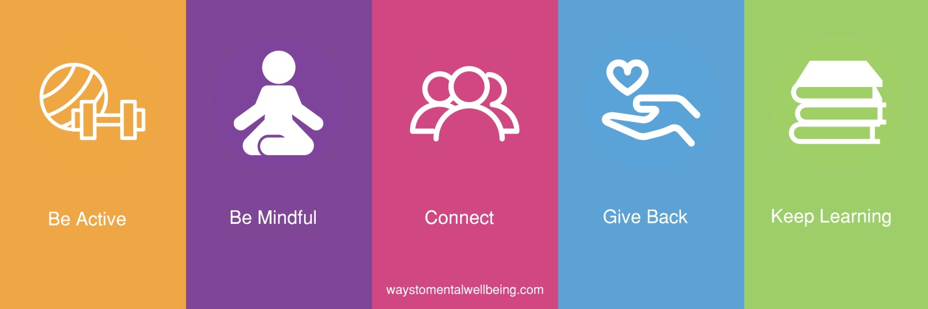
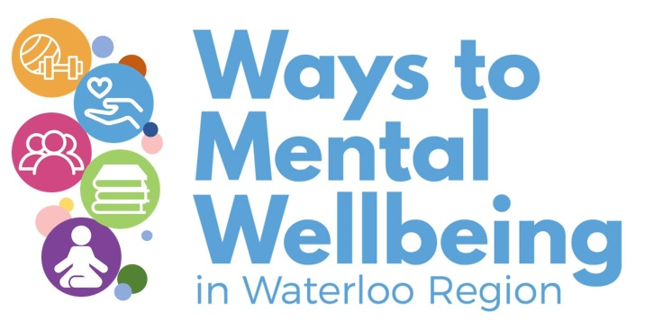 | If you want to get information out about ways to achieve mental wellbeing amongst your workplace or clients, find the tools you need at: https://www.waystomentalwellbeing.com/
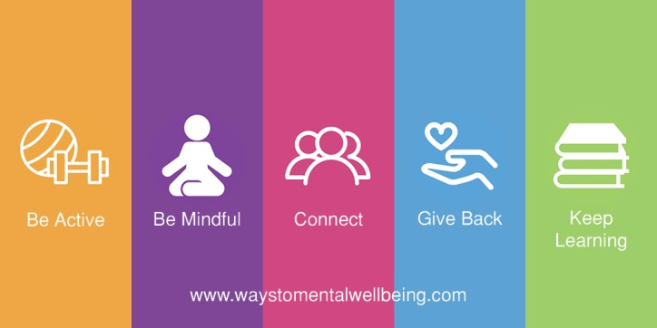 | Have you heard of The Ways to Mental Wellbeing? Practicing the ways can improve mental health!  https://www.waystomentalwellbeing.com/
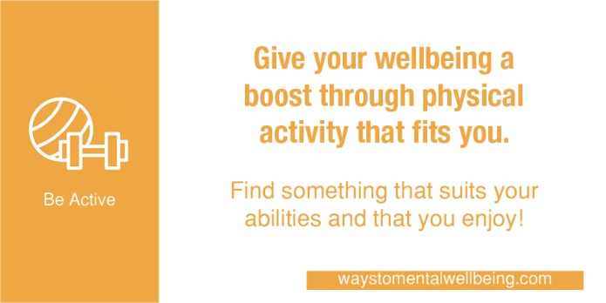 | When possible, add movement to your day. Small changes like taking the stairs can improve your mental wellbeing as much as it improves your physical health. https://www.waystomentalwellbeing.com/
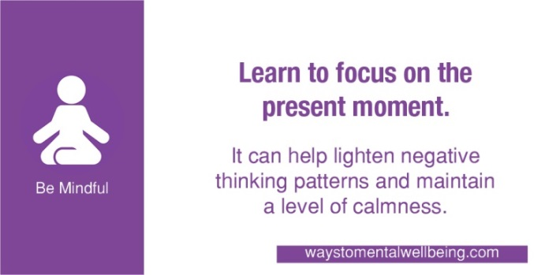 | Savour the moment, whether you are on a train, eating lunch or talking to friends. Be aware of the world around you and what you are feeling.  https://www.waystomentalwellbeing.com/
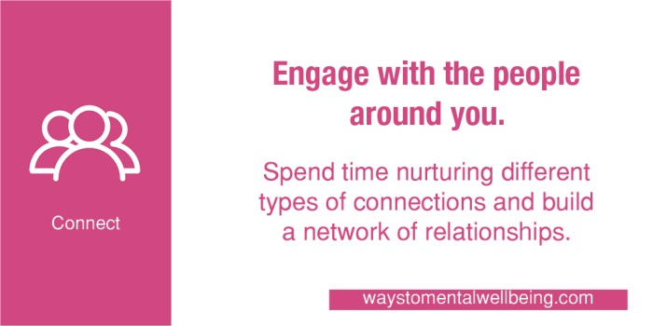 | Whether you are at home, work, school, or in your local community, connect with those around you. Invest time in developing connections. https://www.waystomentalwellbeing.com/
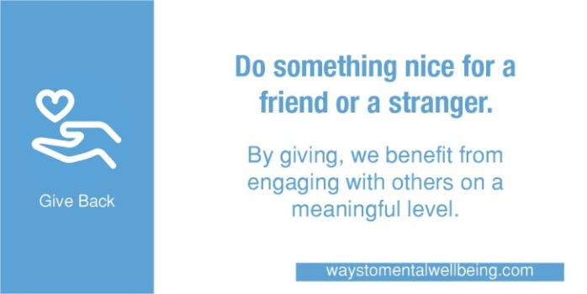 | Giving to others can take our thoughts away from our own concerns and help us see the bigger picture. https://www.waystomentalwellbeing.com/
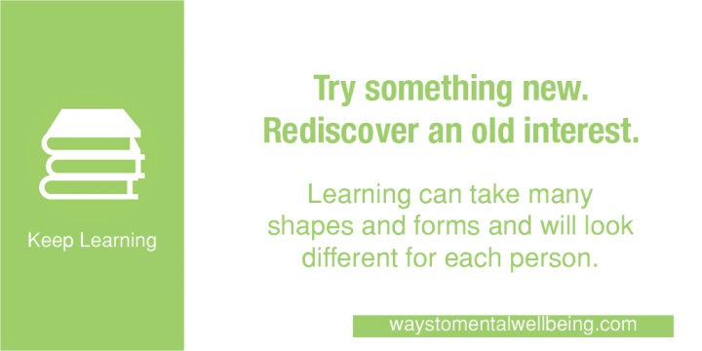 | Learning helps us to gain insight into life, ourselves and the world around us. It also has a positive effect on maintaining mental wellbeing. https://www.waystomentalwellbeing.com/

Facebook
Cover Image
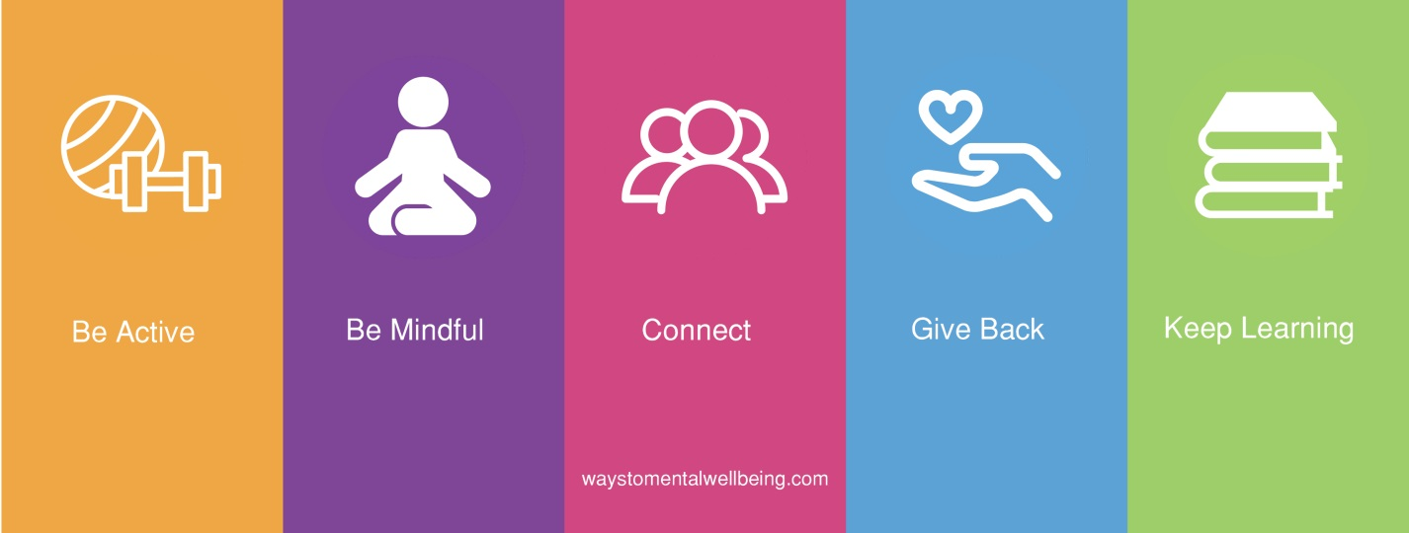
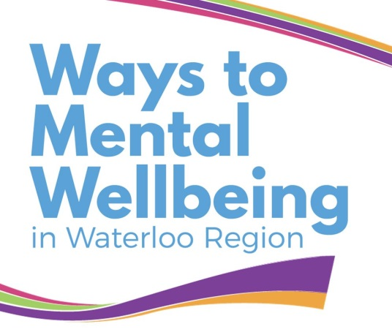 | DYK there is a website with tools, activities, and programs to help you to promote wellbeing inside and outside your organization!  https://www.waystomentalwellbeing.com/
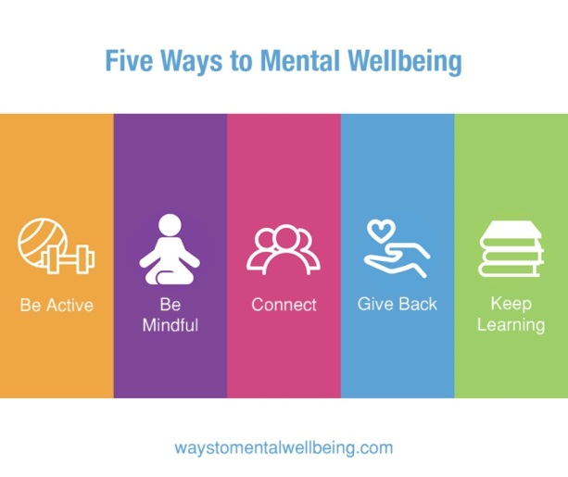 | Have you heard of The Ways to Mental Wellbeing? Practicing the ways can improve mental health! https://www.waystomentalwellbeing.com/
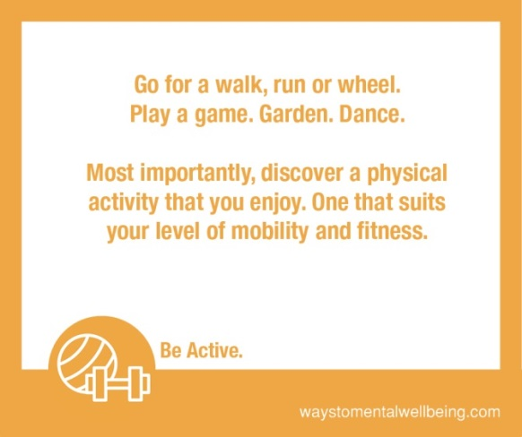 | While focusing on fitness can seem like a big commitment, we can all be physically active in some way every day. The important part is finding activities that suit your abilities and that you enjoy!  https://www.waystomentalwellbeing.com/
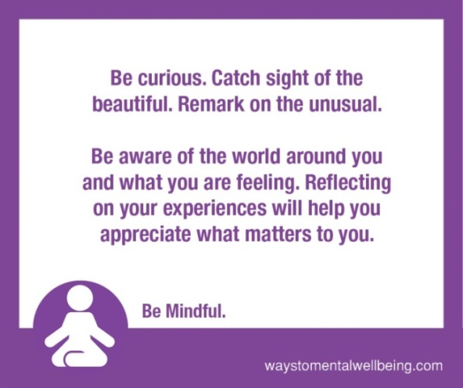 | For many of us, our minds are constantly working. We are focused on making plans, worrying about deadlines, making to-do lists, jumping from task-to-task, or thinking about upcoming appointments.  Learning to focus on the present moment can help lighten negative thinking patterns and maintain a level of calmness.  https://www.waystomentalwellbeing.com/
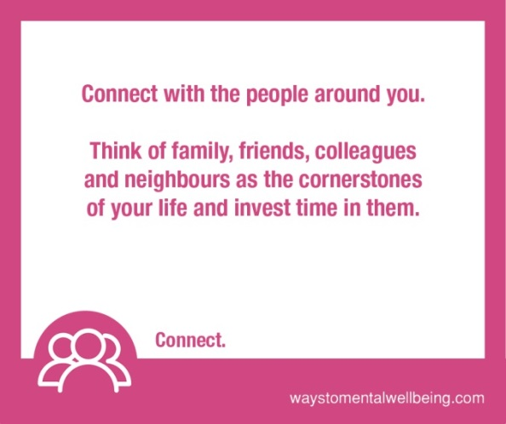 | Beyond connections with family and friends, sharing interests with others in our community can help us feel connected to something bigger than ourselves.  To improve our mental health and wellbeing, it’s important to spend time nurturing these connections in order to build a network of relationships.  https://www.waystomentalwellbeing.com/
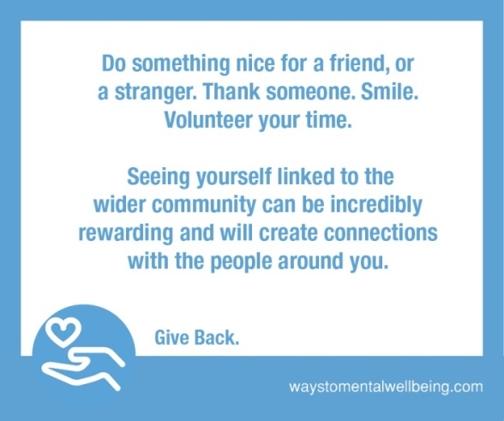 | Giving back to others improves not only our own mental health and wellbeing but also the wellbeing of others.  https://www.waystomentalwellbeing.com/
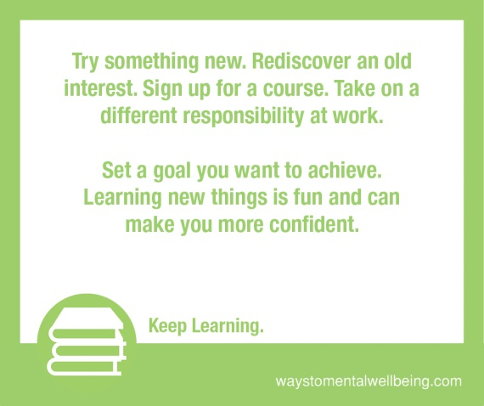 | There are many ways to learn outside of a formal classroom. Learning is about gaining new knowledge, developing new skills and refining old ones which are important for both personal and professional growth.  https://www.waystomentalwellbeing.com/

Partner accounts to tag: @ROWPublicHealth
Relevant hashtags to use: #WellnessWednesday, #WaystoMentalWellbeing, #MentalHealth, #LetsTalk

